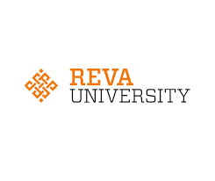

**SMART FARMER ASSISTANT**

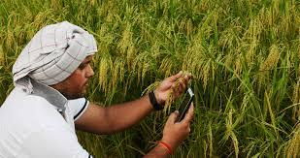



**SMART FARMER ASSISTANT**

India being an agrarian country, it is our responsibility to assist our farmers to get the right price for their yield. Agriculture is an important sector which plays a crucial role in the development of a country's economy. The farmers are the backbone of our country. Due to lack of knowledge and exposure for our farmers, their yield has a low output. So, we need to assist our farmers in direct trading and ease of business together with the Government so that they are more profitable. Henceforth, a user-friendly Mobile App would help farmers for the same with the inbuilt trade process.

This proposed idea facilitates the farmer to get live-time guidance with the help of Green-link app powered by the P∆ST (Portable Analytic Soil Tester). P∆ST is a user-friendly device designed to assist the farmers in determining the fertility of soil live-time. Green-link is a simple yet efficient app designed to improve the connectivity to a farmer. The smart and compact device is capable of predicting the type of crop that can be cultivated in the plot based on the fertility of the soil. It assures real-time guidance in all vernacular languages making the design user convenient. Our future plans are to automate the whole farming procedures to make our farmers smart and effective in their work.